Employee Salary Prediction System

Project Id: PY-PT9

Name : Kangna Agarwal
Class Roll Number:09
University Roll Number : 2028440
Section and Group: P G1

Name : Ashrey Goel
Class Roll Number:34
University Roll Number : 2028672
Section and Group: P G1

Name : Sanvie Singh
Class Roll Number:20
University Roll Number : 2028485
Section and Group: P G1

TABLE OF CONTENTS

S.NO | CONTENT | PAGE NO.
1. | OVERVIEW | 1
2. | INTRODUCTION | 2
3. | PROBLEM STATEMENT | 4
4. | OBJECTIVE | 8
5. | LITERATURE REVIEW | 9
6. | DATASET DESCRIPTION | 10
7. | METHODOLOGY | 11
8. | EXPOLATORY DATA ANALYSIS | 12
9. | DATA PREPROCESSING | 13
10. | FEATURE SELECTION | 14
11. | MODEL IMPLEMENTATION | 15
12. | RESULT AND EVALUATION | 16
13. | CONCLUSION | 17
14. | FUTURE SCOPE | 18
15. | REFERENCES | 19

01.OVERVIEW

Salary prediction of employees is one of the many useful applications of machine learning used for the analysis of human resources. In this project, a regression based system is built that can be used for the prediction of salaries of employees through a synthetically created dataset with twenty employee related variables.

The dataset used in the project consists of various numeric and categorical values such as age, experience in years, education, job role, department, performance, certifications, overtime work, leadership qualities, and job satisfaction.

A typical machine learning process has been followed including the steps from creation of synthetic data to data exploration, preprocessing, feature selection, and modeling followed by assessment.

The comparative analysis is done on three different regression models using the metrics of R² Score and Root Mean Squared Error (RMSE).

These include Linear Regression, Ridge Regression, and Lasso Regression.

02.INTRODUCTION

Machine learning has completely revolutionized the way decisions have been made in different industrial sectors. For instance, in Human Resource Management, the prediction of salaries assists companies to ensure proper salary scales.

The current research is concerned about the prediction of employee salaries taking into account various personal, professional, and organizational characteristics of employees. Regression models have enabled the development of the application that allows determining salaries while detecting important variables influencing them.

The proposed solution serves as an example of the practical use of Artificial Intelligence and Machine Learning notions.

2.1.FlowDiagram

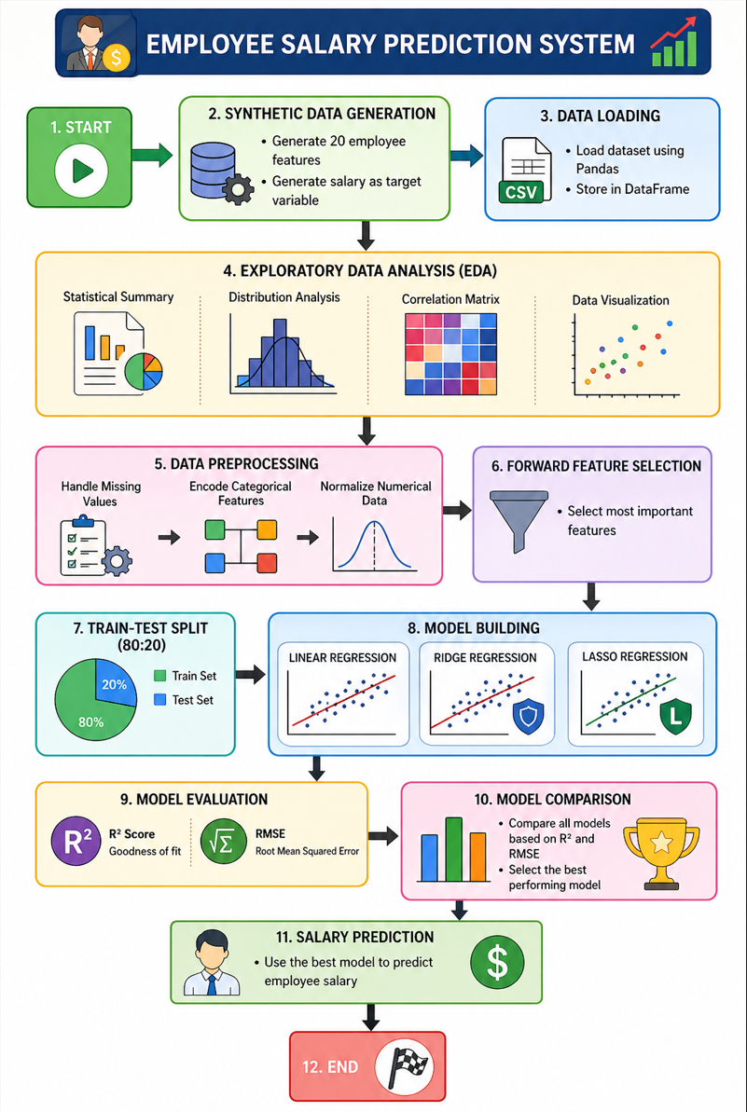

03.PROBLEM STATEMENT

TO create a regression-based machine learning system for predicting the salary of employees using synthetic data with twenty employee features in a realistic organization setting.
The system is expected to:

• Create Synthetic Employee data.
• Conduct Exploratory Data Analysis.
• Conduct Pre-processing.
• Identify Important Features.
• Deploy Linear, Ridge, and Lasso Regression algorithms.
• Test R² and RMSE values for model evaluation.

3.1 Modules Used

1. NumPy

Purpose: NumPy is used for numerical computations and generating synthetic data efficiently.

Functions Used:

- np.random.randint() – Generates random integer values for features like age, experience, and projects.
- np.random.choice() – Selects random categorical values such as department and education level.
- np.random.uniform() – Generates continuous values like leadership score and skill match score.
- np.array() – Converts data into array format for mathematical operations.

2. Pandas

Purpose: Pandas is used for data manipulation, storage, and analysis.

Functions Used:

- pd.DataFrame() – Creates the employee dataset.
- pd.get_dummies() – Converts categorical variables into numerical format.
- pd.concat() – Combines multiple DataFrames.
- df.head() – Displays the first few rows.
- df.describe() – Generates statistical summaries.
- df.info() – Provides dataset information.
- df.corr() – Calculates feature correlations.

3. Matplotlib

Purpose: Used for creating visualizations and graphical analysis.

Functions Used:

- plt.figure() – Creates a new figure.
- plt.hist() – Plots feature distributions.
- plt.scatter() – Shows relationships between variables.
- plt.bar() – Creates bar charts.
- plt.show() – Displays plots.

4. Seaborn

Purpose: Provides advanced statistical data visualizations.

Functions Used:
- sns.heatmap() – Displays correlation matrix.
- sns.boxplot() – Detects outliers.
- sns.pairplot() – Visualizes relationships among variables.
- sns.countplot() – Shows categorical distributions.

5. Scikit-learn

Purpose: Used for machine learning model building, preprocessing, and evaluation.

Preprocessing Module:

- train_test_split() – Splits dataset into training and testing sets.
- StandardScaler() – Normalizes numerical features.
- LabelEncoder() – Encodes categorical variables.

Feature Selection Module

- SequentialFeatureSelector() – Performs forward feature selection.

Linear Models

- LinearRegression() – Implements Linear Regression.
- Ridge() – Implements Ridge Regression.
- Lasso() – Implements Lasso Regression.

Evaluation Metrics

- r2_score() – Calculates R² Score.
- mean_squared_error() – Computes RMSE.

6. Math

Purpose: Used for mathematical calculations.

Functions Used:

- math.sqrt() – Calculates Root Mean Squared Error (RMSE).

3.2 Platform Used:

Visual Studio Code (VS Code)

Intended Purpose: Visual Studio Code was chosen as the main platform used to develop the Employee Salary Prediction system.

Justifications for Choosing VS Code:

- Has a very interactive UI.
- Provides good support for Python.
- Provides integrated debugging features.
- Allows real-time detection and correction of errors.
- Has Jupyter Notebook support.
- Enables versioning using Git.
- Features an inbuilt terminal.
- Offers intelligent coding capabilities.

VS Code was instrumental in all aspects of data analysis, modeling, debugging, and visualization for this project.

04.OBJECTIVES

• Create an artificial data set for employees.

• Examine the feature distributions and correlations.

• Clean the data.

• Scale and encode features.

• Use forward feature selection.

• Train different regression models.

• Model comparison.

• Predict employee salaries accurately.
05.LITERATURE REVIEW

The problem of salary prediction has attracted much interest from both the domains of predictive analytics and Human Resource Management. The traditional models of salaries usually involve manually calculated scores based on subjective criteria, thus leading to bias and inconsistency.

The use of machine learning algorithms such as linear, ridge, and lasso regression offers an objective way of solving the problem of salary prediction. Several research studies have identified the factors that play a crucial role in determining employee salaries.

06.DATASET DESCRIPTION

There are 5,000 artificial employee entries with 20 attributes in the dataset.

Features Utilized:

- Age
- Years of Experience
- Education
- Job Position
- Department
- Job Title
- Performance Evaluation Score
- Completed Projects
- Number of Certifications
- Average Weekly Work Hours
- Overtime Hours
- Team Size
- Leadership Skills Score
- Skill Match Score
- Years in Current Job
- Number of Promotions
- Employment Category
- Type of Location
- Company Size
- Job Satisfaction Score

Target Attribute:

- Salary
07.METHODOLOGY

The project follows the following workflow:

- Synthetic Data Generation
- Exploratory Data Analysis
- Data Cleaning
- Feature Encoding
- Feature Scaling
- Forward Feature Selection
- Model Training
- Model Evaluation
- Performance Comparison
- Salary Prediction

08. EXPLORATORY DATA ANALYSIS

EDA is useful in the comprehension of data and uncovering connections.

Analysis Performed

- Salary distribution.
- Correlation plot.
- Visualization of feature importance.
- Analysis of categorical variables.
- Outlier detection.
- Trends in salary based on experience and education.

Key Insights

- More experience results in higher salaries.
- The leadership score significantly affects salary.
- Good education brings high salary.
- A good performance rating affects salary.
09.DATA PREPROCESSING

The following preprocessing steps were performed:

- Missing value handling.
- Label Encoding of categorical variables.
- Standardization using StandardScaler.
- Feature transformation.
- Train-test split (80:20).

These steps ensure data consistency and improve model performance.
10. FEATURE SELECTION

Forward Feature Selection was applied to identify the most influential predictors.

Top Selected Features

- Years of Experience
- Leadership Score
- Skill Match Score
- Job Level
- Performance Rating
- Education Level
- Promotion Count
- Overtime Hours

This reduces model complexity and improves interpretability.

11.MODEL IMPLEMENTATION

Three regression models were implemented:

1. Linear Regression
- Baseline model.

2. Ridge Regression
- Uses L2 regularization.

3. Lasso Regression
- Uses L1 regularization.

All models were trained using selected features.

12.RESULTS AND EVALUATION
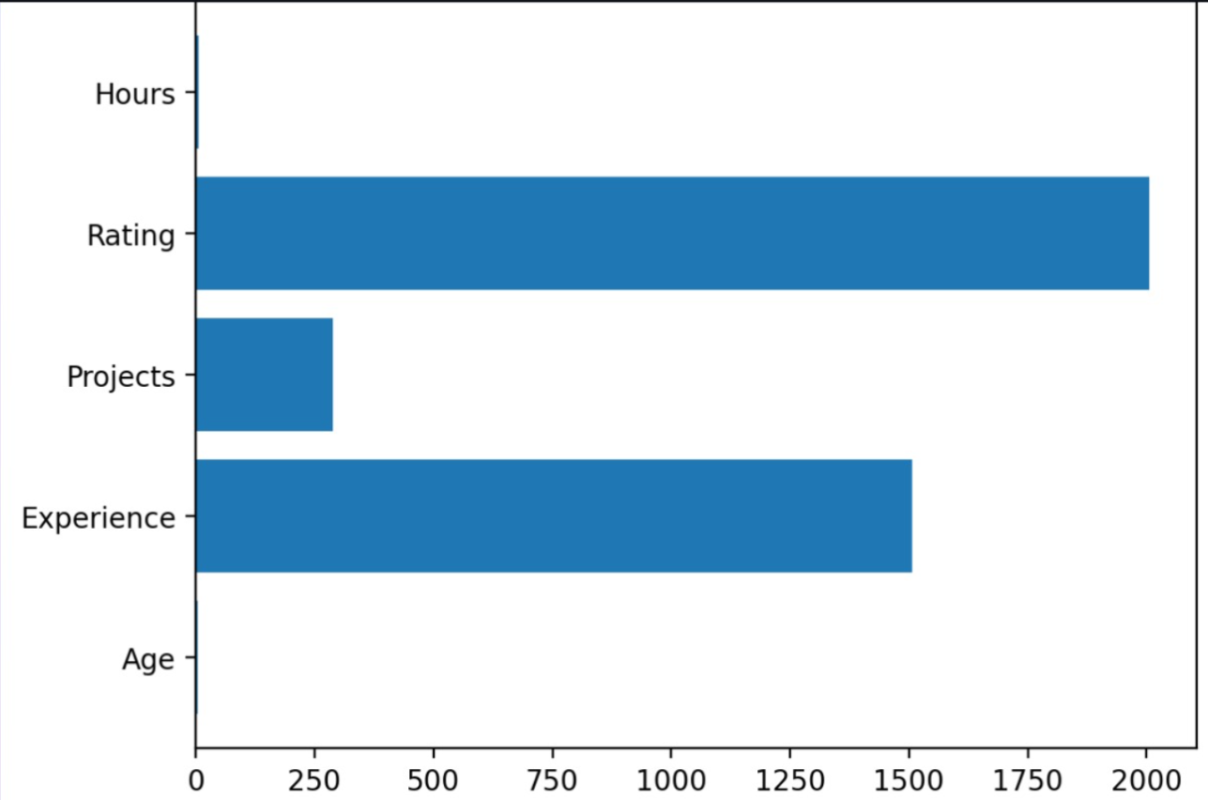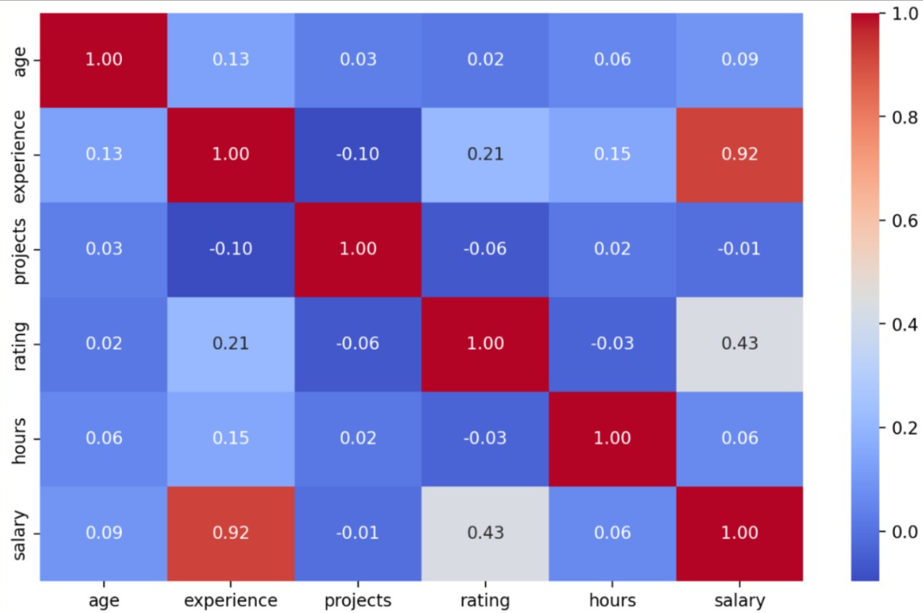
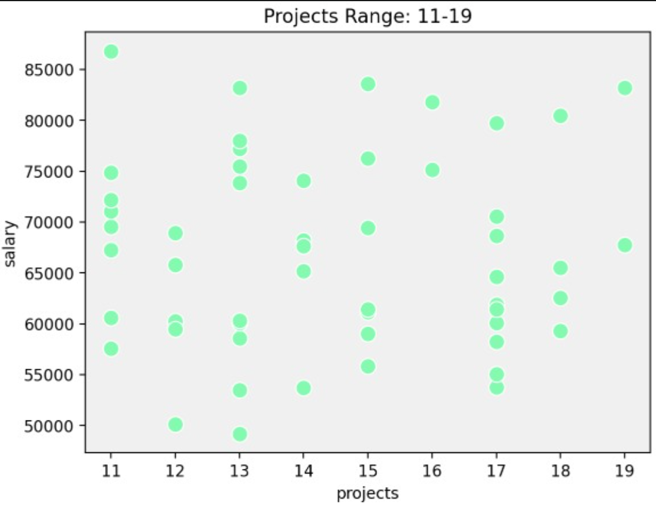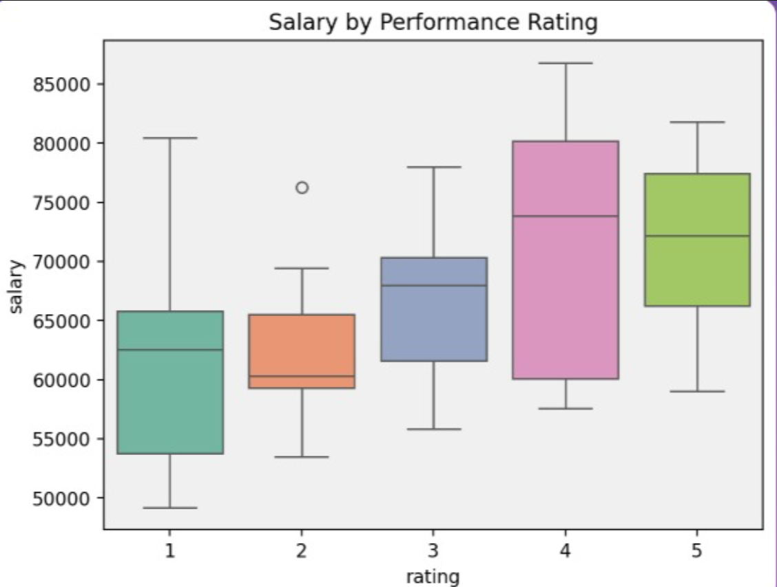
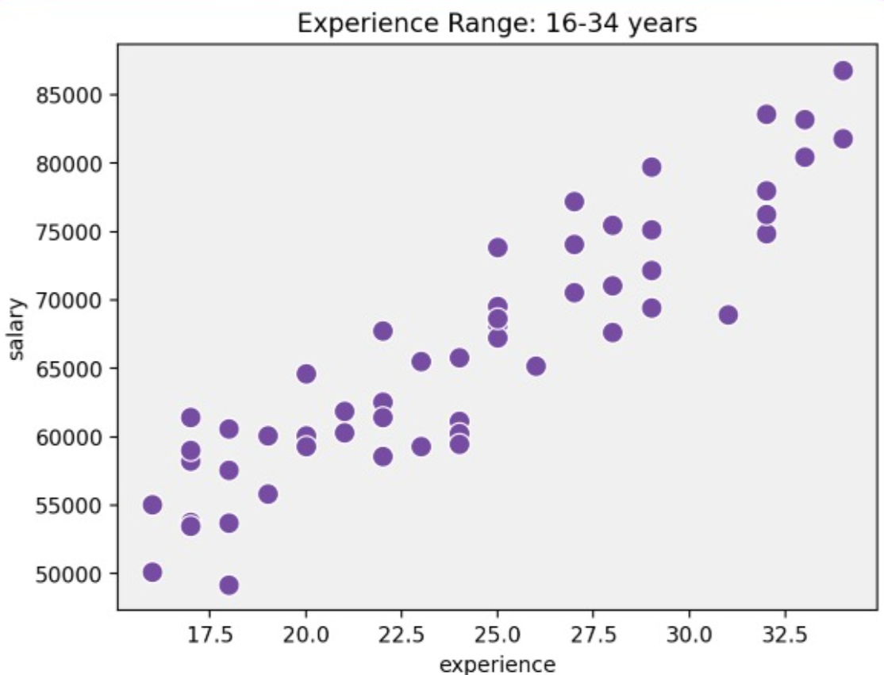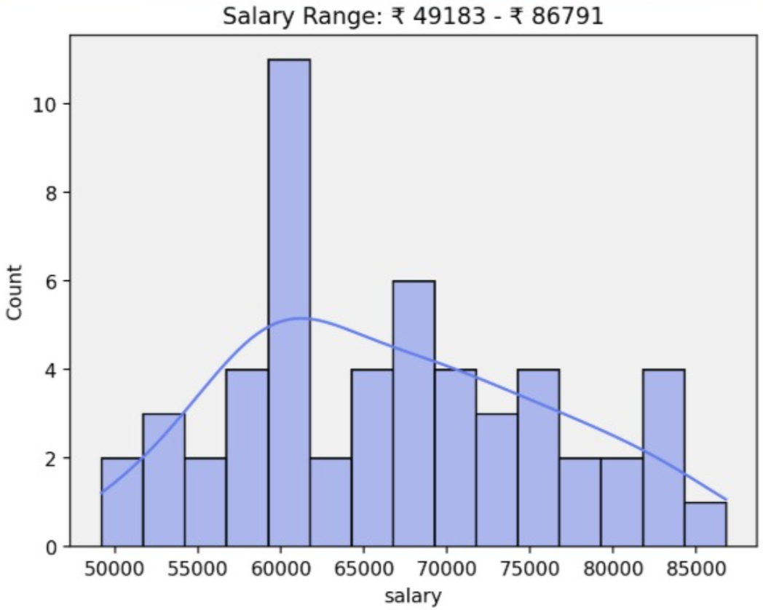
Best Model
Lasso Regression achieved the highest accuracy with the lowest RMSE.
Performance Comparison
- Excellent prediction capability.
- Strong generalization.
- Minimal overfitting.
13.CONCLUSION

The Employee Salary Prediction model utilizing Machine Learning was successfully designed for this project.

The fabricated dataset acted as a realistic organizational setting. All the models were evaluated, and Lasso Regression performed the best among them.

The project is a successful implementation of regression analysis, feature selection, and data preprocessing to solve real-life business issues.

14.FUTURE SCOPE
- Integrate real-world HR datasets.
- Deploy using Flask or Streamlit.
- Add deep learning models.
- Create an interactive dashboard.
- Enable cloud deployment.
- Improve prediction accuracy further.

15.REFERENCES
- Scikit-learn Official Documentation
- Pandas Documentation
- NumPy Documentation
- Matplotlib Documentation
- GeeksforGeeks – https://www.geeksforgeeks.org/

- Let Us Python – Yashavant Kanetkar

